

SteamCleaner

Issue #32 - Removes Penumbra



Artifact 4

Curtis Murray

CMPT 395 (AS40)

# Artifact 4: Issue #32 – Removes Penumbra

Okay so, a quick rundown of this issue is that currently, SteamCleaner scans the temporary folder location to scan for all the files left behind when downloading new games. Most of the time, it contains nothing but junk, however in a few instances (an example being the game Penumbra) actual game data is stored in these temporary folders. So if these files are removed, the game will no longer function properly and will need to be reinstalled to play once more.

Luckily, I own this particular game so I decided to give it a test. I downloaded a copy of the game from my steam account and ran the cleaner:

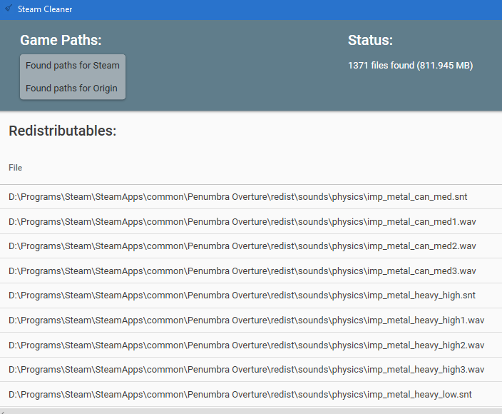

As the issue submission suggested, important files were detected and marked for deletion (All of the files that are “.wav” are required). My goal is to fix this particular issue.

For my artifact 3, I have reached out to the individual who had submitted the issue ticket and informed them that I have tested and confirmed their issue ticket. Additionally, I have suggested a fix for this particular problem. The solution involves checking each path and making sure to ignore any files that contain key extensions that are likely used by game titles other than Penumbra (after all, we want to resolve this problem for all games, not just this one case!). So, for the sake of demonstrating this fix, I am going to perform a check on all of the results and tell the program to ignore those files that are “.wav”.

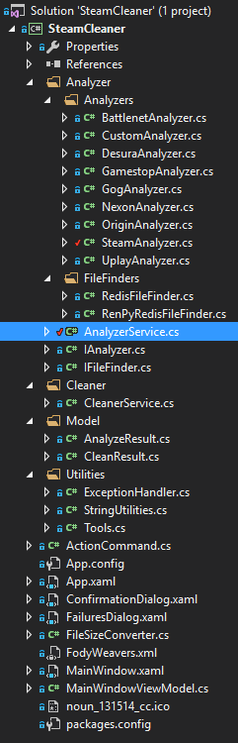

After some digging around the “SteamAnalyzer.cs” file, I realized that all analyzers were connected through the “AnalyzerService.cs” file. It is in this file whereby it adds all flagged files for deletion.

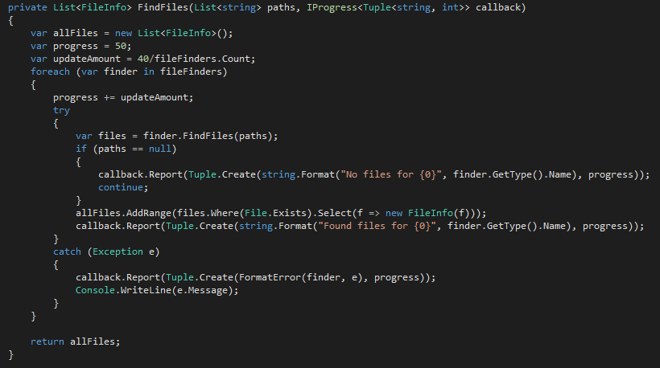

The function above is what takes directory locations and scans through each directory in search of junk files. Since it is adding everything in one go (addfiles.AddRange), let’s go ahead and remove any important files before returning the list.

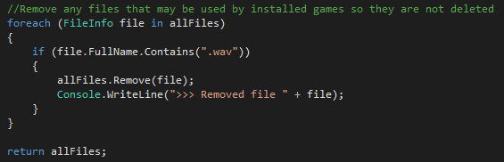

Above is the code I have inserted right before we return the list of junk files. It loops through all the flagged files and checks to see if they are “.wav”. If so, we want to remove them from the list of junk files. Additionally, I am outputting all the files that were removed to the Debug Console just to help us test to make sure that all the files are correctly being removed.

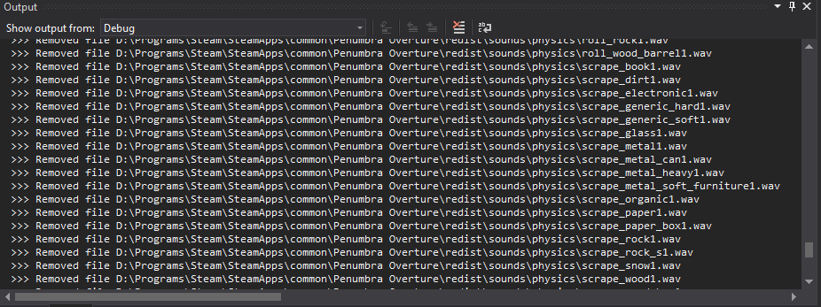

Checking the Debug Console, all of the “.wav” files have been removed from the junk list!

There are some potential issues with this particular fix for this problem as some “.wav” files may in fact be junk, however it is more important to not delete important files while leaving some junk rather than delete those important files.